La Belle Bakery — Website Hosting on AWS EC2
Author: Olabisi Lawal

Table of Contents

Lab 2 — Hosting a Website on AWS EC2

Part 1 — Description
Host the La Belle Bakery website on an Amazon EC2 instance so the site is served from a virtual server rather than object storage. The objective is to provision an EC2 instance, configure networking and security, connect via PuTTY (SSH), install and configure a web server (Apache or Nginx), deploy the site files, and verify public access via the instance public IP or an Elastic IP. Tools and AWS features used: EC2, Security Groups, Elastic IP (optional), PuTTY, and standard Linux web server packages.

Part 2 — Preparation
- Created local site files: index.html; about.html; menu.html; styles.css; logo.png; hero.jpg; product photos.
- Selected AMI (Amazon Linux 2) and instance type t2.micro.
- Created/used key pair and converted .pem to .ppk for PuTTY.
- Prepared Security Group allowing SSH (22) from my IP and HTTP (80) from 0.0.0.0/0.
- Installed PuTTY and PuTTYgen on Windows; verified IAM permissions for EC2 actions.

Part 3 — Observations
1. Launched an EC2 instance named labellebakerymajor using Amazon Linux. Selected instance type t2.micro and attached the key pair.
2. Created/updated a Security Group to allow SSH (port 22) from my IP and HTTP (port 80) from anywhere. Confirmed rules in the EC2 console.
3. Allocated and associated an Elastic IP to the instance to provide a stable public IP.
4. Converted the .pem key to .ppk using PuTTYgen. Connected via PuTTY using the instance public IP and verified login.
5. Installed Apache or Nginx, deployed site files to the web root, and configured permissions.
6. Opened the instance public IP in a browser and confirmed the La Belle Bakery homepage loaded correctly.
Troubleshooting:
- SSH connection refused — Confirmed Security Group and key settings.
- 403 Forbidden — Fixed file ownership and permissions.
- CSS/images not loading — Verified file paths and content types.
- Service not starting — Checked logs and installed missing packages.

Part 4 — Screenshots
- Screenshot 1 — EC2 Instance List
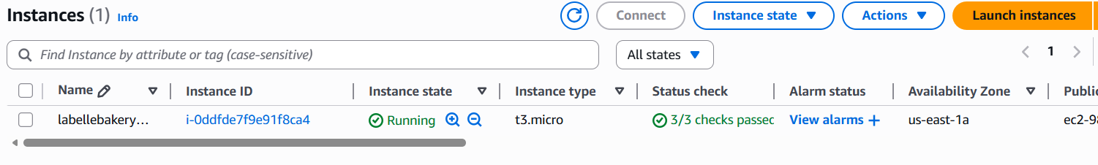
- Screenshot 2 — Public Website View
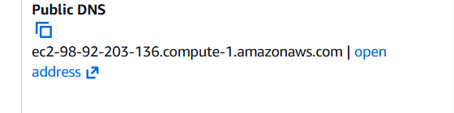
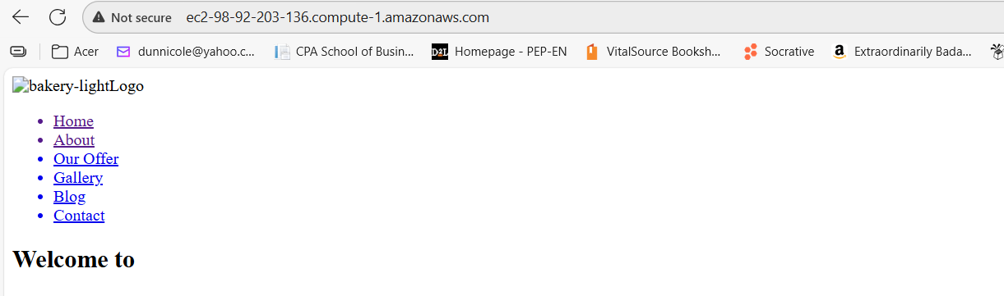

Part 5 — Reflection
Hosting La Belle Bakery on EC2 provided hands-on experience with provisioning and managing cloud-based virtual servers. It required understanding of networking, SSH access, and Linux server administration. The process highlighted the flexibility of EC2 compared to S3, especially in terms of control over the environment and software stack.
For production environments, additional considerations include automation, monitoring, and security hardening. Using EC2 allows for dynamic scaling and integration with other AWS services, but also introduces complexity in maintenance and cost management.
Key takeaway: Running a site on EC2 gives full server control and flexibility but requires more operational overhead than S3; for production, combine EC2 with load balancing, HTTPS, and automation for reliability and security.

References
AWS documentation: Amazon EC2 instance launch and management; Security Groups; Elastic IPs; connecting with SSH.

